***Smart water management***

**Perform data visualization :**

# Data Collection:

Gather relevant data on water usage, quality, and infrastructure. This could include data from sensors, historical records, or other sources.

## **Data Cleaning:**

Clean and preprocess the data to remove any inconsistencies or missing values.

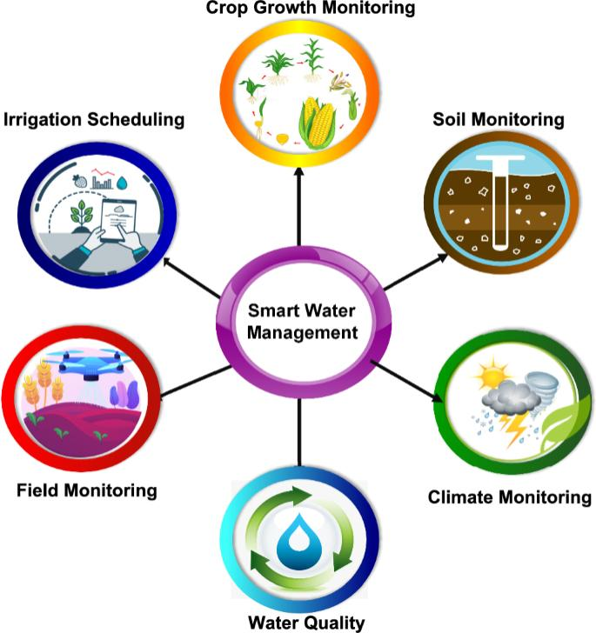**Choose Visualization Tools:**

Select appropriate data visualization tools or software. Common choices include Python libraries like Matplotlib, Seaborn, or data visualization platforms like Tableau.

**Select Visualization Types:**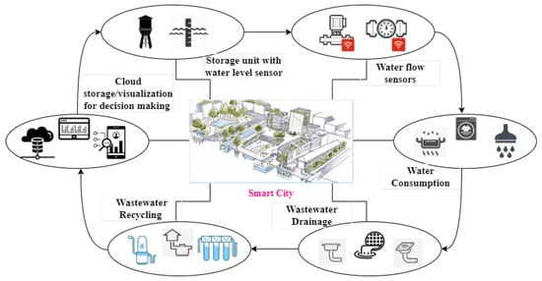

Use line charts to show trends in water consumption over time.

Create bar charts to compare water usage in different areas or sectors.

Design heatmaps to display water quality variations across regions.

Utilize geographic maps to pinpoint areas with water management issues.

Pie charts can be used to represent the distribution of water usage in different sectors.

Interactive Dashboards: Consider building interactive dashboards with tools like Tableau or Power BI. This allows users to explore data on their own.

**Data Storytelling:**

Narrate a story through your visualizations. Explain the significance of the data and the impact of smart water management.

**Real-time Monitoring:**

If possible, set up real-time data visualization to enable immediate responses to water-related issues.

**Predictive Analysis:**

Implement predictive models and visualize forecasts related to water usage and quality.

**Incorporate IoT:**

If available, integrate data from IoT devices like water quality sensors for real-time updates.

**Share Insights:**

Share your visualizations with stakeholders, government agencies, or the public to promote awareness and informed decision-making in smart water management.